CIS211: Data Structures

Delaware Tech, Computer Technology Department

Wilmington

(Instructor: Lee Hsu)

Java Review: Comparable

//From Liang 10Ed.

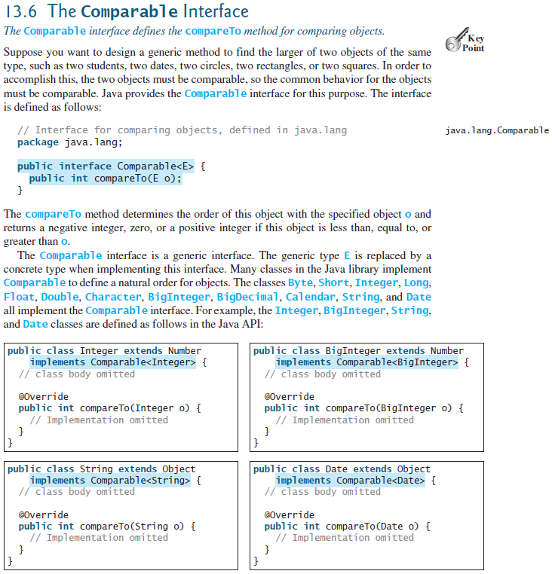

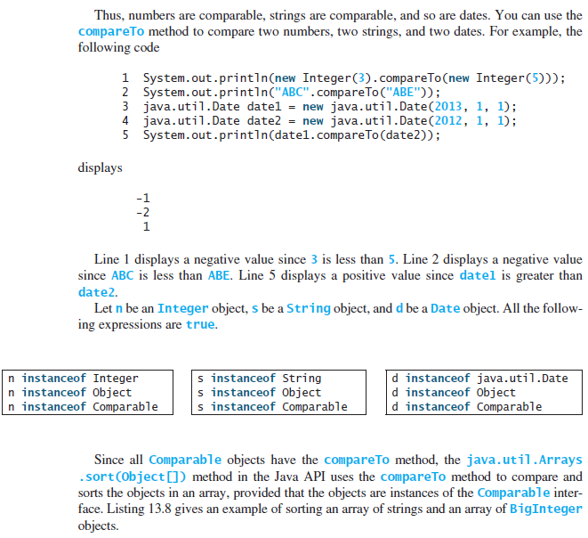

//13.8

import java.math.*;

public class SortComparableObjects {

public static void main(String[] args) {

String[] cities = {"Savannah", "Boston", "Atlanta", "Tampa"};

java.util.Arrays.sort(cities);

for (String city: cities) System.out.print(city + " ");

System.out.println();

BigInteger[] hugeNumbers = {new BigInteger("2323231092923992"),

new BigInteger("432232323239292"),

new BigInteger("54623239292")};

java.util.Arrays.sort(hugeNumbers);

for (BigInteger number: hugeNumbers) System.out.print(number + " ");

}

}

//13.9

public class ComparableRectangle extends Rectangle

implements Comparable<ComparableRectangle> {

public ComparableRectangle(double width, double height) {

super(width, height);

}

@Override // Implement the compareTo method defined in Comparable

public int compareTo(ComparableRectangle o) {

if (getArea() > o.getArea()) return 1;

else if (getArea() < o.getArea()) return -1;

else return 0;

}

public String toString() {

return "Width: " + getWidth() + " Height: " + getHeight() + " Area: " + getArea();

}

}

//13.10

public class SortRectangles {

public static void main(String[] args) {

ComparableRectangle[] rectangles = {

new ComparableRectangle(3.4, 5.4),

new ComparableRectangle(13.24, 55.4),

new ComparableRectangle(7.4, 35.4),

new ComparableRectangle(1.4, 25.4)};

java.util.Arrays.sort(rectangles);

for (Rectangle rectangle: rectangles) {

System.out.print(rectangle + " ");

System.out.println();

}

}

}

The Interface Comparable (From Your Text pages 235~235)

* Consider the method **compareTo** for class **String**
* if *s* and *t* are strings, **s.compareTo(t)** is
  + Negative if *s* comes before *t*
  + Zero if *s* and *t* are equal
  + Positive if *s* comes after *t*
* By invoking **compareTo**, you compare two objects of the class **T**.
* LISTING JI3-3 The interface **java.lang.Comparable**

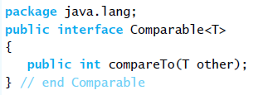

* Create a class **Circle,** define **compareTo**

